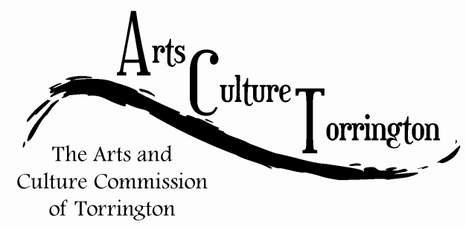

ACT MEETING MINUTES
October 25, 2017| 8:30am | City Hall Auditorium

Attendance: Ed Cannata, Marie Soliani, Jacques Williams, Stacey Caren, Janet Iffland, Kim McAllister, Tim Waldron, Rachel Kelly, Mike McAllister

The meeting was called to order by Chairman Ed Cannata at 8:35am

A motion was made to add an agenda item “motion to approve minutes of 9/27/17 meeting” made by Rachel Kelly, seconded by Kim McAllister.

A motion was made to approve the minutes of the previous meeting by Kim McAllister, seconded by Janet Iffland. All voted in favor

Community Engagement discussion – the suggestion was floated to host a meeting at Five Points Gallery, hosted by ACT, with the goal inviting artists, arts organizations, etc to engage in a discussion with the commission on their needs in the community, introduce each other, etc. The event would take place in January. A motion to proceed was made by Mike McAllister, seconded by Janet Iffland.

Artspace discussion – Jacque Williams reported that the Artist Relocation program was recently highlighted by AARP with city planner Marty Connor. The commission discussed incorporating the artspace concept into the Working Cities Challenge. Ed Cannata suggested inviting Marty to the next meeting to discuss ways ACT can become involved again with the artist relocation program. A motion was made by Janet Iffland, seconded by Mike McAllister to allow Jacque to become the ACT liaison to the Working Cities Challenge, the motion passed unanimously.

Christmas Ornaments – the commission discussed the ornament project at length. Ed Cannata announced that he had approached First Act Bakery and Petricone’s Pharmacy to be highlighted as ornaments. Commission members voiced concern that these ornaments were not keeping in line with historical/cultural locations. The commission also discussed the issue of the ornaments not making a profit for ACT. A motion was made by Marie Soliani, seconded by Stacey Caren to forego the ornament project this year. The motion failed on a 3-4 vote. A second motion was made by Mike McAllister, seconded by Janet Iffland to only do the Torrington Historical Society, contingent upon the Historical Society being able to front the seed money. This motion passed by a vote of 6-1.

Discussion was tabled regarding the City Hall photo project.
Discussion was tabled regarding the John Brown property project.

A motion was made by Marie Soliani to adjourn the meeting, the motion was seconded by Stacey Caren. The meeting was adjourned at 9:25am.

Respectfully submitted,
Tim Waldron

