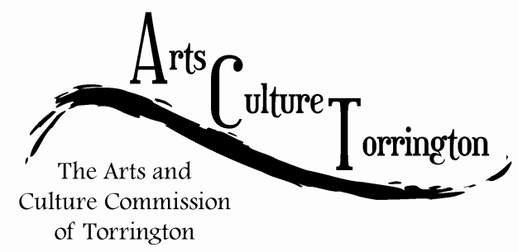

ACT MEETING MINUTES
January 31, 2018| 8:30am | City Hall Auditorium

Attendance: Ed Cannata, Bill Haygood, Eric Hammer, Mike McAllister, Kim McAllister, Rachel Kelly, Janet Iffland, Jacque Williams, Tim Waldron

The meeting was called to order by Chairman Ed Cannata at 8:35am

A motion was made by Mike McAllister to open the meeting to the public. A member of the Torrington Trails Network was present and discussed different fundraiser ideas to help raise money.

The commission began discussing the municipal ordinance which outlines the responsibilities for ACT. Members discussed whether or not to seek changes to the ordinance but did not decide to move forward. Ed Cannata suggested adding a marketing aspect to the commissions goals, to promote arts & culture. Other suggestions brought up included serving as an advocacy group for local businesses, setting a benchmark for inventory of arts & culture assets in Torrington and showing growth in Torrington. Rachel Kelly said she would reach out to the Northwest Arts Council to find data. Commissioners were tasked with coming up with goals for the upcoming year.

Rachel Kelly made a motion to convene on Tuesday, February 20th at 8:00am to discuss the Artist Relocation Program. The motion was seconded by Kim McAllister and approved with all in favor.

Ed Cannata suggested that better marketing efforts were needed for 2018.

The commission discussed “Torrington Arts District” banners. Bill Haygood offered to create some schematics.

The commission discussed Saturday in the Park and settled on June 9th as the event date. The Parks & Recreation Department will include the event in their upcoming Spring/Summer guide.
Eric Hammer updated the group regarding efforts to install lighting to illuminate the public art installation on the rear of the Staples building.

A motion was made to adjourn the meeting by Rachel Kelly, seconded by Jacque Williams. The meeting was adjourned at 9:45am.

