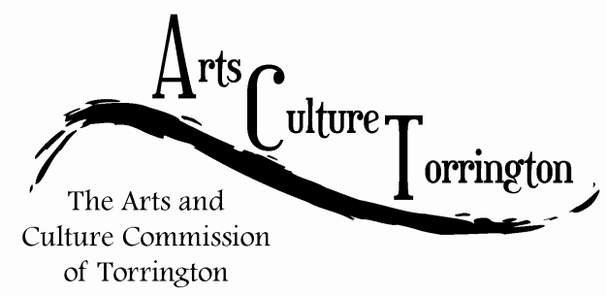

ACT MEETING MINUTES
August 30, 2017| 8:30am | City Hall Auditorium

Attendance: Ed Cannata, Marie Soliani, Bill Haygood, Rachel Kelly, Jacques Williams, Stacey Caren, Janet Iffland, Tim Waldron

The meeting was called to order by Chairman Ed Cannata at 8:36am

Public Comment: Lisa Soliani-Croci, owner of Hatfield Jewelers, addressed the commission with an idea that she was working on with other downtown merchants. The “Creepy Crawl” would take place on Friday the 13th in October and would involve merchants getting involved and offering a promotion, or offer to individuals who visited their store or restaurant on that night. The event would also coincide with the Warner Theatre showing the film Hocus Pocus. Lisa was inquiring whether the commission would like to be involved. Commissioners were intrigued and supportive.

Jacque Williams made a motion, seconded by Bill Haygood, to place discussion of ACT involvement with the Creepy Crawl on the agenda. The commission discussed with Lisa possible ways ACT could help support the event. This included, marketing, signage, social media, etc. A motion was made by Jacque Williams, seconded by Bill Haygood, to formally approve the commission working with the Creepy Crawl. A special meeting would take place on Wednesday, September 6th at 8:30am to further discuss the event.

The minutes of the previous meeting were approved on a motion made by Jacque Williams, seconded by Stacy Caren.

Community engagement update: Rachel Kelly reported that she is finalizing the process for the contest for a new ACT logo. She is working on getting the website pages up and running.

City space – the second historic photo was recently hung on the 2nd floor of City Hall. The adjoining plaque will be installed soon. Ed Cannata suggested that the next installation could possibly be a montage of the installation of the Daughters of the American Revolution fountain which is located outside City Hall. The commission then discussed the hanging system for the City Hall Auditorium. The total cost is approximately $250. The commission discussed getting donations and or possibly small grants to help cover this expense.
Holiday ornaments – the commission discussed the plans for the 2017 Holiday Ornaments. This year, several merchants had voiced a desire to do their own ornament and ACT would serve as the administrator for them in addition to having their own “ACT” ornament. Commissioner Soliani disagreed with this concept. The commission discussed using the Hotchkiss Fyler House as their selected building for this year. No further action was taken.
Discussion on the ArtSpace initiative was tabled due to time constraints.

The meeting was adjourned on a motion made by Janet Iffland, seconded by Marie Soliani at 9:3am.

Respectfully submitted,
Tim Waldron

