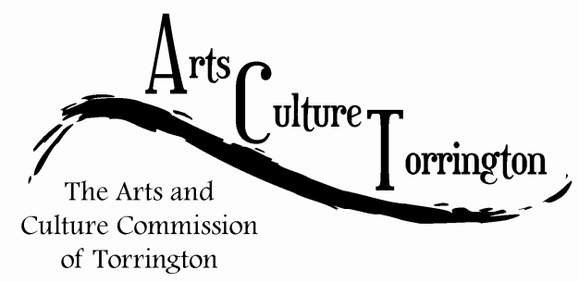

MEETING AGENDA
June 27, 2018 | 8:30am | City Hall Auditorium

- Call To Order
- Public Comment
- Artist Relocation Update
- Holiday Ornaments Update
- CitySpace Update
- Downtown Banners Update
- Budget Update
- New business
- Adjourn

