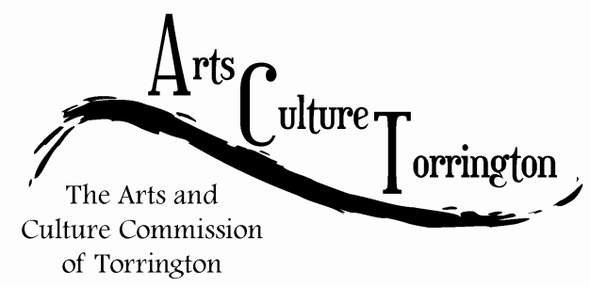

MEETING AGENDA
January 31st 2018 | 8:30am | City Hall Auditorium

- Call To Order
- Approve Minutes
- Public Comment
- Recap public outreach forum
- Review Ordinance Chapter 3A - ARTS AND CULTURE COMMISSION
- Discussion – 2018 Direction/Goals
- New business
- Adjourn

