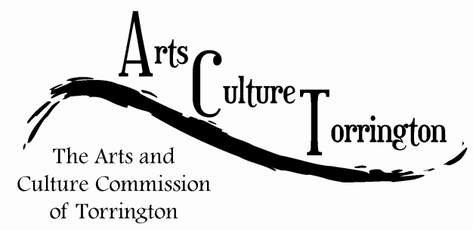

MEETING AGENDA
February 27, 2018 | 8:00am | City Hall Auditorium

- Call To Order
- Approve Minutes
- Public Comment
- Saturday in the Park
- Artist Relocation Program
- New business
- Adjourn

