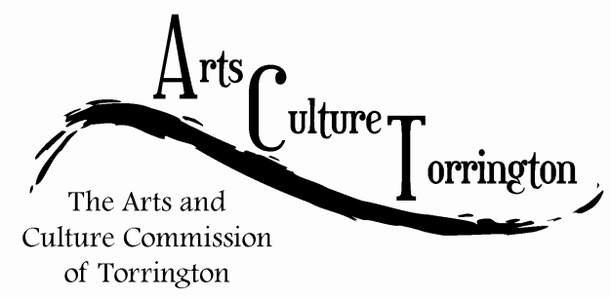

MEETING AGENDA
September 27th, 2017 | 8:30am | City Hall Auditorium

- Call To Order
- Creepy Crawl update
- City Hall photo project update
- Discussion on John Brown birthplace property
- Adjourn

